H.T No
Regulations:
A15

Sreenidhi Institute of Science and Technology
(An Autonomous Institution)
Code No: 5B518 Date: 25-Jan-2025 (AN)

B.Tech III-Year I- Semester External Examination, January - 2025 (Supplementary)
Design of Machine Members-I (ME)

Time: 3 Hours Max.Marks:75 Note: a) No additional answer sheets will be provided.
b) All sub-parts of a question must be answered at one place only, otherwise it will not be valued.
c) Missing data can be assumed suitably.

Bloom's Cognitive Levels of Learning (BCLL)
Remember | L1 | Apply | L3 | Evaluate | L5
Understand | L2 | Analyze | L4 | Create | L6

Part - A Max.Marks:25

Answer all QUESTIONS.
 |  | BCLL | CO(s) | Marks
1 | State Poisson's ratio. | L1 | CO1 | [2M]
2 | Define notch sensitivity. | L1 | CO2 | [2M]
3 | List any four applications of a riveted joints. | L1 | CO3 | [2M]
4 | Define spring index. Write its importance. | L1 | CO4 | [2M]
5 | Write the expression for the maximum efficiency of riveted joint. | L1 | CO5 | [2M]
6 | Write the assumptions made in the design of welded joint. | L1 | CO6 | [3M]
7 | How to reduce stress concentration factor in machine elements? | L2 | CO2 | [3M]
8 | List any four applications of leaf spring. | L1 | CO4 | [3M]
9 | List the different types of keys. | L2 | CO5 | [3M]
10 | Discuss the concept of stiffness in bending. | L2 | CO1 | [3M]

Part – B Max.Marks:50
ANSWER ANY FIVE QUESTIONS. EACH QUESTION CARRIES 10 MARKS.

 |  |  | BCLL | CO(s) | Marks
11. | a) | Discuss the design considerations in the design of machine elements. | L2 | CO1 | [5M]
 | b) | Discuss the following: (i) Maximum shear stress theory  (ii) Maximum principal strain theory. | L3 | CO1 | [5M]
12. | a) | Describe the different types of cyclic stress. | L2 | CO2 | [5M]
 | b) | A cantilever beam made of cold drawn steel 20C8 (σut = 540 N/mm²) is subjected to a completely reversed load of 1000 N as shown in Figure. The notch sensitivity factor q at the fillet can be taken as 0.85 and the expected reliability is 90%. Determine the diameter of the bar for a life of 1000 cycles.  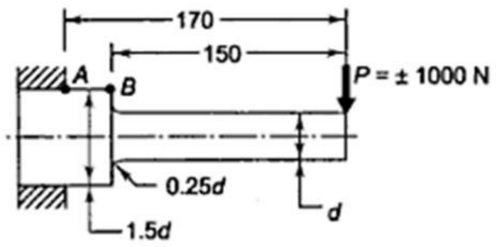 | L3 | CO2 | [5M]
13. |  | It is required to design square key for fixing a pulley on the shaft, which is 50 mm in diameter. The pulley transmits 10 kW power at 200 rpm to the shaft. The key is made up of steel 45C8 (Syc = Syt = 380 N/mm2) and the factor of safety is 3. Determine the dimensions of the key. Take Ssy = 0.577Syt). | L3 | CO3 | [10M]
14. | a) | A helical compression spring of a cam-mechanism is subjected to an initial preload of 50N. The maximum operating force during the load cycle is 150N. the wire diameter is 3mm, while the mean coil diameter is 18mm. the spring is made up of oil-hardened and tempered valve spring wire of grade-VW (S_{ut}=1430 N/mm²). Determine the factor of safety used in the design on the basis of fluctuating stresses. | L4 | CO4 | [5M]
 | b) | Wahl’s factor is to be considered in the design of helical compression or tension springs-Justify. | L2 | CO4 | [5M]
15. | a) | A double riveted double cover butt joint in plates 20 mm thick is made with 25 mm diameter rivets at 100 mm pitch. The permissible stresses are: σ_{t} = 120 MPa; τ = 100 MPa; σ_{c} = 150 MPa. Calculate the efficiency of joint | L4 | CO5 | [5M]
 | b) | A double riveted double cover butt joint in plates 20 mm thick is made with 25 mm diameter rivets at 100 mm pitch. The permissible stresses are: σ_{t} = 120 MPa; τ = 100 MPa; σ_{c} = 150 MPa. Calculate the efficiency of joint | L2 | CO5 | [5M]
16. | a) | A bracket carrying a load of 15 kN is to be welded as shown in Figure. Find the size of weld required if the allowable shear stress is not to exceed 80 MPa.  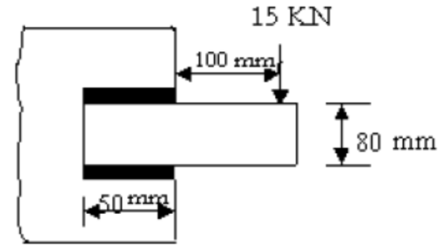 | L3 | CO6 | [5M]
 | b) | Classify the welded joints. | L2 | CO6 | [5M]
17. | a) | Explain the concept of design procedure. | L2 | CO1 | [4M]
 | b) | Explain the factors to be influencing the endurance stress. | L2 | CO2 | [3M]
 | c) | List any two applications and advantages of knuckle joint. | L1 | CO3 | [3M]
18. | a) | Define the solid length and spring constant. | L2 | CO4 | [4M]
 | b) | Explain the bolts of uniform strength giving examples of practical applications of such bolts. | L2 | CO5 | [3M]
 | c) | Write the expression for the tensile strength of the joint for double fillet weld. | L3 | CO6 | [3M]

-- 00 -- 00 –

